DATA ANALYSIS WITH R — C997

1. In this assignment, I will create a linear regression analysis to predict the size of the population in the state of Texas based on the Census website dataset.

(See step by step below)

1. After downloading the U.S. Census dataset (nst-est2019-alldata.csv) from the U.S. Census Bureau, I simply copied the line for Texas population into a new spreadsheet and named the file “Texas.xlsx”.

Then, I imported the file using R.

For graphing purposes, I assigned X and Y labels to columns.

Then I used basic scatter plot with gradient and regression line.

1. Here is the R script that provides a statistical description.

1. Predicting the population size in five years using a linear regression

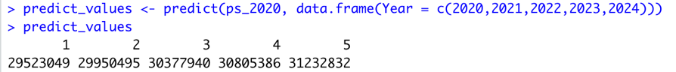

Plotting using scatter plot.

E.   Acknowledge sources: None

F.   Professional content demonstration.